Spring in the churchyard by Marjorie Middleton
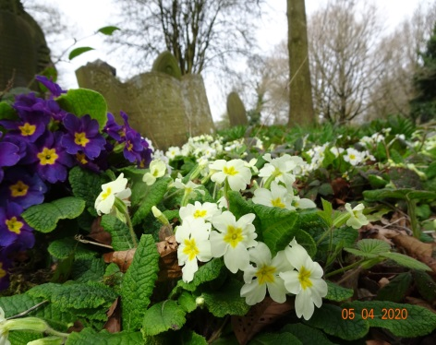
Spring is in glorious full swing in the churchyard. The warm April weather has encouraged fresh new leaves to burst, giving the trees a bright green haze. Vibrant colour is everywhere with daffodils, forget-me-nots, primroses and glossy celandines all flowering together. The wild garlic is also coming into flower and when you walk along the paths, its pungent smell wafts through the air.
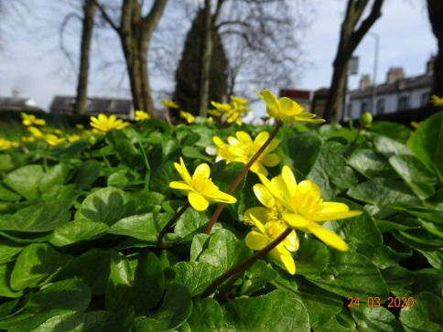
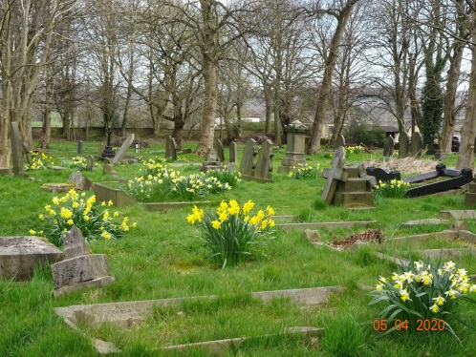
Insects are emerging after their winter hibernation with the large queens of buff tailed, tree and common carder bumblebees all searching for nest sites. Butterflies are also on the wing : so far peacock, small tortoiseshell and the dainty orange tip have been sighted, often alighting on gravestones warmed by the spring sunshine.
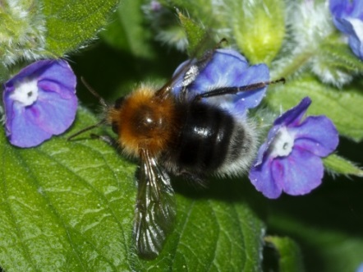
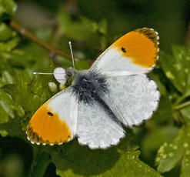
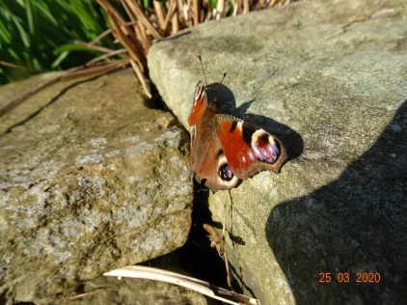

Early in the morning, the air is full of birdsong as the males announce their territories. The rich notes of the first blackbird song in spring, always lifts the spirits. It is joined by wren, robin, mistle thrush, chaffinch, goldfinch, blue tit and great tit. Blue tits are nesting in several of our bird boxes, including an open-fronted one designed for robins!
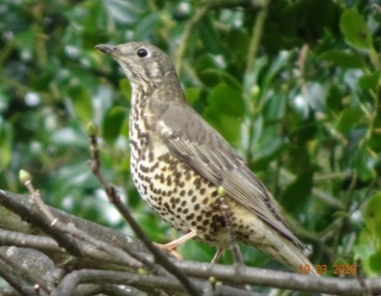
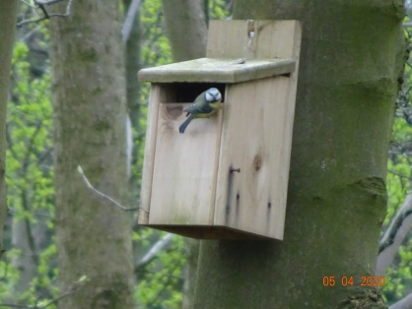
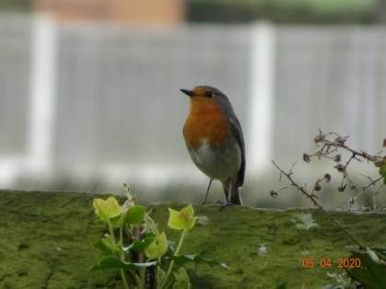

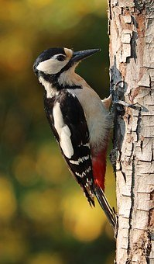
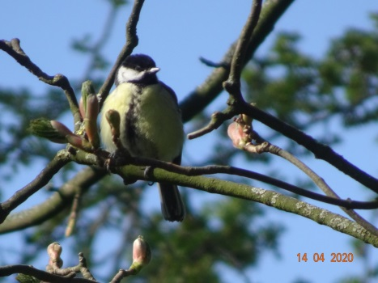
I watched this great tit with its beak stuffed with moss flying into a nest box on a sycamore tree, thickly cloaked in ivy. Once inside the box, it must be adding wood shavings to the nest - there was persistent tapping coming from within! The drumming of a great spotted woodpecker can also be heard in the churchyard, accompanied by its sharp “chick chick” call.
Whatever the problems in the human world, it’s business as usual in the natural world.

